Donna Stroupe
F a s h i o n D e s i g n e r

Let me introduce myself, I am a fashion designer who has 7 years of experience in this job. I am very experienced in various fashion styles for all seasons and I have made various models for men and women for a world famous brand.

Education Work Experience
Bachelor of Design Layout Fashion Designer
2012 - 2015 2012 - 2015
Larana School of Fashion and Design RimberioFradel Studio
Already made all the styles for all

seasons and made all the designs to be more sold.

Bachelor of Design
2012 - 2015
Larana School of Fashion and Design
Already made all the styles for all seasons and made all the designs to be more sold.

Pro Skills
Wedding Gowns Modern Design Textile Patterns
Trend Forecasting
Already made all the styles for all seasons and made all the designs to be more sold.
Already made all the styles for all seasons and made all the designs to be more sold.

Layout Fashion Designer
2012 - 2015
RimberioFradel Studio
Already made all the styles for all seasons and made all the designs to be more sold.
Already made all the styles for all seasons and made all the designs to be more sold.

Layout Fashion Designer
2012 - 2015
RimberioFradel Studio
Already made all the styles for all seasons and made all the designs to be more sold.

Drawing Sketch Digital Drawing
References
Juliana Silva Reese Miller

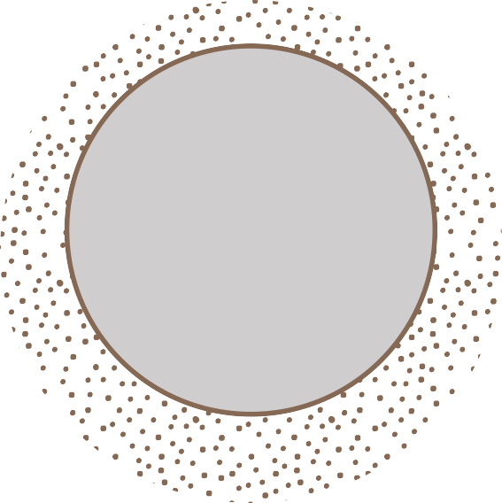Wardiere Inc. / CEO 123-456-7890
Wardiere Inc. / CEO 123-456-7890

